Software Architecture Overview

a. High-Level Architecture Design
The architecture of TheReminder is built upon a layered architectural model tailored for mobile applications developed with Flutter. This model ensures a clear separation of concerns, modularity, and ease of maintenance, which is critical when addressing diverse user needs, particularly in an accessibility-focused application.
The architecture is composed of five primary layers:

1. Presentation Layer
This is the topmost layer and serves as the interface between the user and the application. It includes:
- Task List / Edit Screens: These screens allow users to interact with tasks—creating, viewing, editing, and deleting them.
- Settings & Accessibility Screen: Enables users to customize accessibility features such as high contrast, text size, and screen reader support.
This layer is responsible for displaying data from the domain layer and capturing user input. It also applies any dynamic accessibility configurations based on user preferences.

2. Domain Layer
This layer acts as the brain of the application. It contains the core logic and decision-making components:
- Task Manager (Singleton): Centralized logic for creating, modifying, and deleting tasks. Implemented as a Singleton to ensure a single source of truth throughout the app.
- Accessibility Manager: Manages visual and interactive accessibility adaptations based on stored preferences.
- User Preferences Manager: Handles retrieval and application of accessibility settings for each user.
- Reminder Scheduler (Strategy + Observer): Dynamically determines which reminder behavior(s) to apply (audio, vibration, visual) and listens for task timing events to trigger them. This component uses:
  - The Strategy Pattern to encapsulate each type of reminder behavior.
  - The Observer Pattern to allow the system to notify the appropriate reminders at runtime when tasks become due.

3. Reminder Strategies
Each strategy corresponds to a distinct method of alerting the user:
- Visual Reminder
- Audio Reminder
- Vibration Reminder
By encapsulating these strategies, the system can flexibly support user preferences without rewriting core reminder logic.

4. Data Layer
This layer is responsible for data persistence and retrieval:
- Task Repository: Acts as an abstraction layer over the data source. It mediates between the domain layer and the underlying database.
- SQLite Database: Local database used to store tasks, user settings, reminder configurations, and accessibility preferences. The sqflite plugin in Flutter is used to interface with this database.

5. Platform Services
These are external services provided by the Android operating system, integrated using Flutter plugins:
- flutter_local_notifications for visual alerts
- Text-to-Speech Plugin for audio reminders
- Vibration Plugin for haptic feedback
These components serve as bridges between high-level application logic and low-level hardware or OS capabilities.

b. Software Architecture Diagram

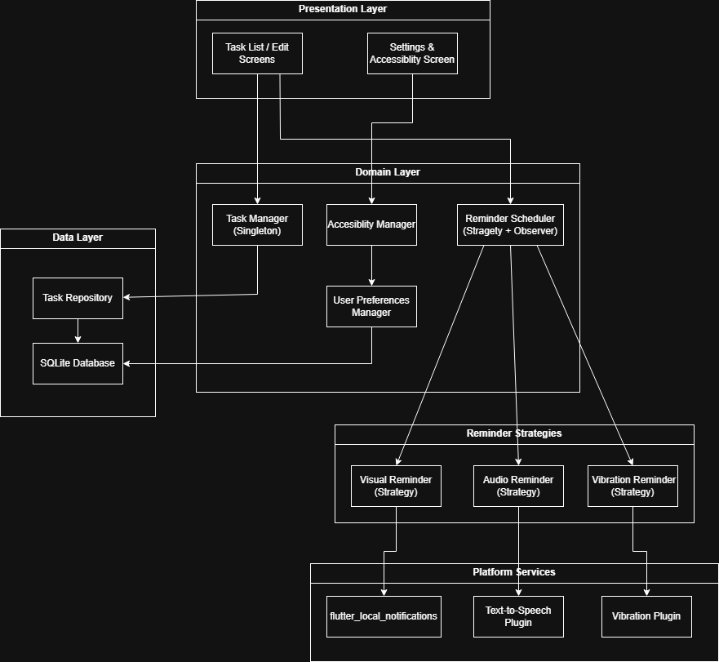

c. How the Architecture Facilitates the Use Cases
Let’s now map the defined use cases to the architecture, demonstrating how each layer and component contributes to supporting them:

Use Case 1: Set Reminder Type
Workflow:
- The Task List/Edit Screen captures the user's reminder preferences during task creation or editing.
- The Task Manager communicates with the Reminder Scheduler.
- The Reminder Scheduler selects the appropriate reminder strategy (audio, visual, or vibration) using the Strategy Pattern.
- The task, with its configuration, is stored via the Task Repository in the SQLite Database.
Supportive Architecture Features:
- Strategy Pattern allows new reminder types to be added without altering core logic.
- Settings are user-driven and dynamically selected at runtime.
- Clean separation between UI and scheduling logic.

Use Case 2: Trigger Reminders
Workflow:
- A background service or timer mechanism in the Reminder Scheduler checks if any tasks are due.
- When triggered, it uses the Observer Pattern to notify the applicable Reminder Strategies.
- These strategies invoke respective platform services:
  - flutter_local_notifications for visual cues.
  - Text-to-Speech for audio alerts.
  - Vibration Plugin for haptic feedback.
Supportive Architecture Features:
- Observer Pattern ensures extensibility; more observers (e.g., wearable alerts) can be added easily.
- Strategy encapsulation makes fallback mechanisms easier to implement if one reminder type fails.
- Platform services are abstracted, reducing coupling and increasing reliability.

Use Case 3: Add Task with Priority & Accessibility
Workflow:
- The user creates a task and sets priority/accessibility options on the Task Screen.
- The Accessibility Manager and User Preferences Manager apply formatting like large font or high contrast.
- The Task Manager saves task metadata including priority and visual flags to the Task Repository.
Supportive Architecture Features:
- Accessibility logic is modular and customizable per user.
- Decorator-like behavior is implied by combining visual styles dynamically at runtime (e.g., applying a “High Priority” badge with enlarged text).
- Ensures consistent experience for users with varying impairments.

Use Case 4: Save/Load Task Data
Workflow:
- When a user creates, modifies, or deletes a task, the Task Manager calls the Task Repository.
- The repository interfaces with the SQLite Database to persist or fetch data.
- Changes are reflected back on the Task List Screen.
Supportive Architecture Features:
- Singleton ensures consistent state across app lifecycle.
- SQLite is local and reliable for offline functionality.
- All database operations are isolated via the repository, making it testable and easier to update.
d. Task Matrix

Task | Responsible
Draft high-level architecture description | All team members
Create architecture diagram | Talha Akbulut
Write explanation of architecture vs use cases | Talha Akbulut
Review and refine architecture components | Özge Doğan
Cross-check design pattern integration | Beyzanur Zeybek
Align architecture with use cases and requirements | Taha Mert Ağım
Final formatting and document submission | Feyza Coşkun

